**Student Information System (SIS)**

**Task 1. Database Design:**

**1. Create the database named "SISDB"**

mysql> create database sisdb;

Query OK, 1 row affected (0.28 sec)

mysql> show databases;

+--------------------+

| Database |

+--------------------+

| information_schema |

| mysql |

| performance_schema |

| sisdb |

| sys |

| testdb |

+--------------------+

6 rows in set (0.00 sec)

**2. Define the schema for the Students, Courses, Enrollments, Teacher, and Payments tables based on the provided schema. Write SQL scripts to create the mentioned tables with appropriate data types, constraints, and relationships. a. Students b. Courses c. Enrollments d. Teacher e. Payment**

mysql> use sisdb;

Database changed

mysql> create table Students(student_id integer(3) primary key,

-> first_name varchar(20),

-> last_name varchar(20),

-> date_of_birth date,

-> email varchar(25),

-> phone_number integer(10)

-> );

Query OK, 0 rows affected, 2 warnings (0.92 sec)

mysql> desc Students;

+---------------+-------------+------+-----+---------+-------+

| Field | Type | Null | Key | Default | Extra |

+---------------+-------------+------+-----+---------+-------+

| student_id | int | NO | PRI | NULL | |

| first_name | varchar(20) | YES | | NULL | |

| last_name | varchar(20) | YES | | NULL | |

| date_of_birth | date | YES | | NULL | |

| email | varchar(25) | YES | | NULL | |

| phone_number | int | YES | | NULL | |

+---------------+-------------+------+-----+---------+-------+

6 rows in set (0.00 sec)

mysql> create table Teacher(teacher_id int(3) primary key,

-> first_name varchar(20),

-> last_name varchar(20),

-> email varchar(25)

-> );

Query OK, 0 rows affected, 1 warning (1.18 sec)

mysql> desc Teacher;

+------------+-------------+------+-----+---------+-------+

| Field | Type | Null | Key | Default | Extra |

+------------+-------------+------+-----+---------+-------+

| teacher_id | int | NO | PRI | NULL | |

| first_name | varchar(20) | YES | | NULL | |

| last_name | varchar(20) | YES | | NULL | |

| email | varchar(25) | YES | | NULL | |

+------------+-------------+------+-----+---------+-------+

4 rows in set (0.00 sec)

mysql> create table Courses(course_id int(3) primary key,

-> course_name varchar(20),

-> credits int(3),

-> teacher_id int(3) references Teacher(teacher_id)

-> );

Query OK, 0 rows affected, 3 warnings (0.46 sec)

mysql> desc Courses;

+-------------+-------------+------+-----+---------+-------+

| Field | Type | Null | Key | Default | Extra |

+-------------+-------------+------+-----+---------+-------+

| course_id | int | NO | PRI | NULL | |

| course_name | varchar(20) | YES | | NULL | |

| credits | int | YES | | NULL | |

| teacher_id | int | YES | | NULL | |

+-------------+-------------+------+-----+---------+-------+

4 rows in set (0.00 sec)

mysql> create table Enrollments(enrollment_id int (4) primary key,

-> student_id int (3) references Students(student_id),

-> course_id int(3) references Courses(course_id),

-> enrollment_date date

-> );

Query OK, 0 rows affected, 3 warnings (0.53 sec)

mysql> desc Enrollments;

+-----------------+------+------+-----+---------+-------+

| Field | Type | Null | Key | Default | Extra |

+-----------------+------+------+-----+---------+-------+

| enrollment_id | int | NO | PRI | NULL | |

| student_id | int | YES | | NULL | |

| course_id | int | YES | | NULL | |

| enrollment_date | date | YES | | NULL | |

+-----------------+------+------+-----+---------+-------+

4 rows in set (0.00 sec)

mysql> create table Payments(payment_id int(4) primary key,

-> student_id int(3) references Students(student_id),

-> amount int(5),

-> payment_date date

-> );

Query OK, 0 rows affected, 3 warnings (0.56 sec)

mysql> desc Payments;

+--------------+------+------+-----+---------+-------+

| Field | Type | Null | Key | Default | Extra |

+--------------+------+------+-----+---------+-------+

| payment_id | int | NO | PRI | NULL | |

| student_id | int | YES | | NULL | |

| amount | int | YES | | NULL | |

| payment_date | date | YES | | NULL | |

**3. Create an ERD (Entity Relationship Diagram) for the database.**

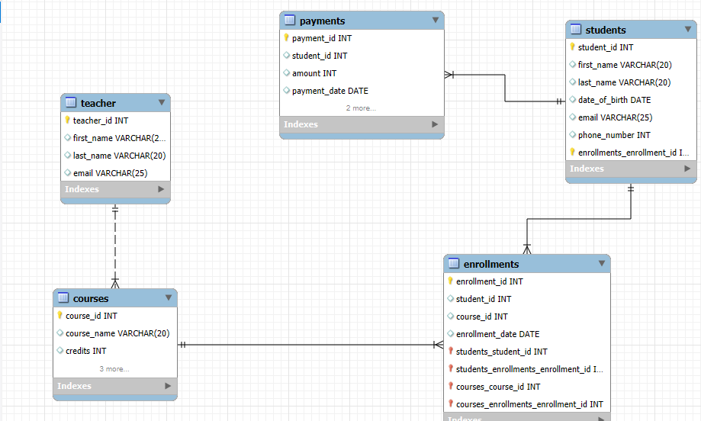

**4. Create appropriate Primary Key and Foreign Key constraints for referential integrity**

CREATE TABLE Students (

-> student_id INT PRIMARY KEY,

-> first_name VARCHAR(50) NOT NULL,

-> last_name VARCHAR(50) NOT NULL,

-> date_of_birth DATE NOT NULL,

-> email VARCHAR(100) UNIQUE NOT NULL,

-> phone_number BIGINT UNIQUE NOT NULL

-> );

CREATE TABLE Teacher (

-> teacher_id INT PRIMARY KEY,

-> first_name VARCHAR(50) NOT NULL,

-> last_name VARCHAR(50) NOT NULL,

-> email VARCHAR(100) UNIQUE NOT NULL

-> );

CREATE TABLE Courses (

-> course_id INT PRIMARY KEY,

-> course_name VARCHAR(100) NOT NULL,

-> credits INT NOT NULL CHECK (credits > 0),

-> teacher_id INT,

-> FOREIGN KEY (teacher_id) REFERENCES Teacher(teacher_id) ON DELETE SET NULL

-> );

CREATE TABLE Enrollments (

-> enrollment_id INT PRIMARY KEY,

-> student_id INT,

-> course_id INT,

-> enrollment_date DATE NOT NULL,

-> FOREIGN KEY (student_id) REFERENCES Students(student_id) ON DELETE CASCADE,

-> FOREIGN KEY (course_id) REFERENCES Courses(course_id) ON DELETE CASCADE

-> );

CREATE TABLE Payments (

-> payment_id INT PRIMARY KEY,

-> student_id INT,

-> amount DECIMAL(10,2) NOT NULL CHECK (amount > 0),

-> payment_date DATE NOT NULL,

-> FOREIGN KEY (student_id) REFERENCES Students(student_id) ON DELETE CASCADE

-> );

**5. Insert at least 10 sample records into each of the following tables.**

**i. Students**

INSERT INTO Students (student_id, first_name, last_name, date_of_birth, email, phone_number) VALUES

(101, 'John', 'Doe', '2000-05-12', 'john.doe@example.com', 9876543210),

(102, 'Jane', 'Smith', '2001-07-15', 'jane.smith@example.com', 8765432109),

(103, 'Michael', 'Brown', '2002-09-20', 'michael.brown@example.com', 7654321098),

(104, 'Emily', 'Davis', '2000-12-05', 'emily.davis@example.com', 6543210987),

(105, 'David', 'Wilson', '2001-03-18', 'david.wilson@example.com', 5432109876);

**ii. Teachers**

INSERT INTO Teacher (teacher_id, first_name, last_name, email) VALUES

(1, 'Alice', 'Johnson', 'alice.johnson@example.com'),

(2, 'Robert', 'Miller', 'robert.miller@example.com'),

(3, 'Emma', 'Garcia', 'emma.garcia@example.com');

**iii.Course**

INSERT INTO Courses (course_id, course_name, credits, teacher_id) VALUES

(201, 'Mathematics', 3, 1),

(202, 'Physics', 4, 2),

(203, 'Computer Science', 3, 3),

(204, 'Biology', 4, 1),

(205, 'Chemistry', 3, 2);

**iv.Enrollments**

INSERT INTO Enrollments (enrollment_id, student_id, course_id, enrollment_date) VALUES

(301, 101, 201, '2024-01-15'),

(302, 102, 202, '2024-01-16'),

(303, 103, 203, '2024-01-17'),

(304, 104, 204, '2024-01-18'),

(305, 105, 205, '2024-01-19');

**V. Payments**

INSERT INTO Payments (payment_id, student_id, amount, payment_date) VALUES

(401, 101, 1500.00, '2024-02-10'),

(402, 102, 2000.00, '2024-02-11'),

(403, 103, 1800.00, '2024-02-12'),

(404, 104, 2200.00, '2024-02-13'),

(405, 105, 1700.00, '2024-02-14');